**DAILY ONLINE ACTIVITIES SUMMARY**

|  |  |  |  |  |  |  |  |  |
| --- | --- | --- | --- | --- | --- | --- | --- | --- |
| **Date:** | **17/07/2020** | | | | | **Name:** | **Spoorthy Balaji** | |
| **Sem & Sec** | **6th & B** | | | | | **USN:** | **4al17cs098** | |
| **Online Test Summary** | | | | | | | | |
| **Subject** | | **-** | | | | | | |
| **Max. Marks** | | **-** | | **Score** | | | **-** | |
| **Certification Course Summary** | | | | | | | | |
| **Course** | **SDP on LATEX** | | | | | | | |
| **Certificate Provider** | | | **-** | | **Duration** | | | **2hours** |
| **Coding Challenges** | | | | | | | | |
| **Problem Statement**: **Python Program for Extended Euclidean algorithms** | | | | | | | | |
| **Status: Solved** | | | | | | | | |
| **Uploaded the report in Github** | | | | | **yes** | | | |
| **If yes Repository name** | | | | | <https://github.com/spoorthybalaji/Daily_Status> | | | |
| **Uploaded the report in slack** | | | | | **yes** | | | |

**ONLINE COURSE**

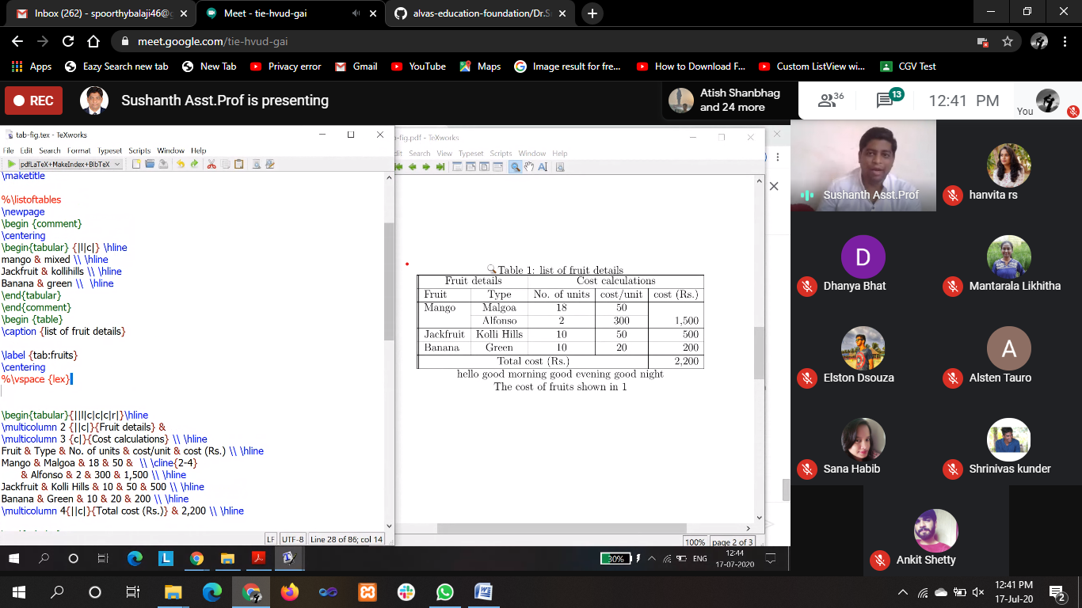

**ONLINE CODING**

**Python Program for Extended Euclidean algorithms**

def egcd(a, b):

if a == 0:

return (b, 0, 1)

else:

gcd, x, y = egcd(b % a, a)

return (gcd, y - (b//a) * x, x)

gcd, x, y = egcd(70, 90)

print(gcd, x, y)

